PROJECT REPORT
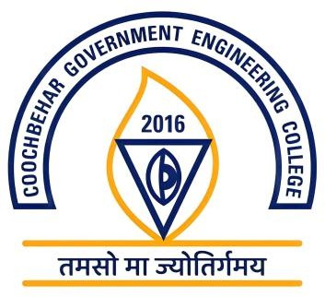
COOCH BEHAR GOVERNMENT ENGINEERING COLLEGE

DEPARTMENT OF COMPUTER SCIENCE & ENGINEERING

Real-Time Indian Sign Language Detection and Recognition Using Deep Learning and Computer Vision

STUDENT DETAILS

STUDENT 1 | STUDENT 2
NAME  Sabir Ali Mondal | NAME  Koushaki Singha
ROLL 34900123032 | ROLL 34900124074
SEMESTER : 7th
MENTOR  Prof. Prabir Kr. Naskar | DEPARTMENT: CSE

